CONFIDENTIAL

Event Live Communications Protocol (Copenhagen)

Overview

The Event Live Communications Protocol (ELCP) is the operating manual for the Copenhagen Communications Team during the live period of Copenhagen 2021. It is arranged in six sections:

- Key personnel in the Communications Team
- Staffing rota and ‘on call’ system
- Includers (volunteers) and their roles
- Communications Centre and other key locations
- Link with Safety Team
- Safety Messaging, Logging & Escalation procedure
- Incident Communications Protocol
- Authorised Spokespersons & Interview Requests

The ELCP does not include granular detail of communications output; this can be found in the Event Communications Plan.

The ELCP covers operational communications in Copenhagen only. Operational communications in Malmö are the responsibility of the Malmö Pride / Malmö stad team and there is a process in place for them to submit content for publication on the Copenhagen 2021 channels. Should there be an escalation or incident in Malmö, the process is outlined in sections 6 and 7 below.

The core communications channels within the Communications Team are email, phone calls and a group chat in Telegram. Due to the busy nature of various communications channels during the event, no other channels should be relied upon. Messenger, WhatsApp and SMS should be actively avoided for urgent communications during this time.

If staffing contingencies need to be made it will be for the Director of Communications to make the decision. If the contingency is required because of the absence of the Director of Communications, the Managing Director or Chair will make the decision.

1. Personnel in the Communications Team

The following staff will be working in the Copenhagen Communications Team during Event Live. Note that some staff members’ role title is different during Event Live to their regular title.

Steve Taylor, Director of Communications & Marketing, has overall responsibility for all communications activity during the event. He is also the person with ultimate responsibility for Escalations and if the Incident Communications Protocol is implemented. He can be contacted by phone 24/7 during the event in case of incident or emergency.

Jemma Tracey, Camilla Engelby, Liv Rossander, Communications Coordinators will coordinate all communications activity including managing Includers and the Communications Centre, supervising social media, dealing with press requests, and handling escalations as necessary. They are only contactable during the hours of their shift.

Najam Ul Assar, Digital Production Manager is responsible for ensuring the successful delivery of live streams from various events assisted by Khayal Trivedi, Digital Coordinator. They are only contactable during the hours of their shift.

Mariya Staugaard & Anders Kungsman, Communications Officers will support the Communications Coordinators and Includers especially in relation to managing enquiries and messages on Zendesk and social media, and logging press requests. They are only contactable during the hours of their shift.

Nanna Matilde Veileborg Bjelka, Social Media Manager (Intern) will manage and coordinate all social media activity via Sprout Social, including curating incoming content.

2. Staffing Rota and ‘On Call’ System

The Communications Team has staff coverage from 0800-2400 every day from 12-20 August, 0800-0100 on 21 August, and 0800-1800 on 22 August. Outside these times the Director of Communications can be called at any time on urgent matters.

The Staff Shift Plan (Sharepoint link) shows which members of staff are on duty at any given time, and also highlights events that they plan to attend during their shift.

There is at all times an On Call Communications Lead, listed in row 5 of the Staff Shift Plan above. During their allocated shift as On Call Communications Lead, the named staff member will be available by phone to the whole team and:

- Is the first point of contact for the Communications Centre volunteers should questions arise
- Is the first point of contact in the Escalation Procedure
- Is the Lead Communications Coordinator should the Incident Communications Protocol be activated

All On Call Communications Leads will have completed a table-top scenario exercise prior to the event.

If the person named as On Call Communications Lead is unable to fulfil their shift for illness or any other reason, they will inform the Director of Communications who will appoint a substitute to take that shift.

If the On Call Communications Lead cannot be reached, the Director of Communications can be contacted by staff or volunteers directly.

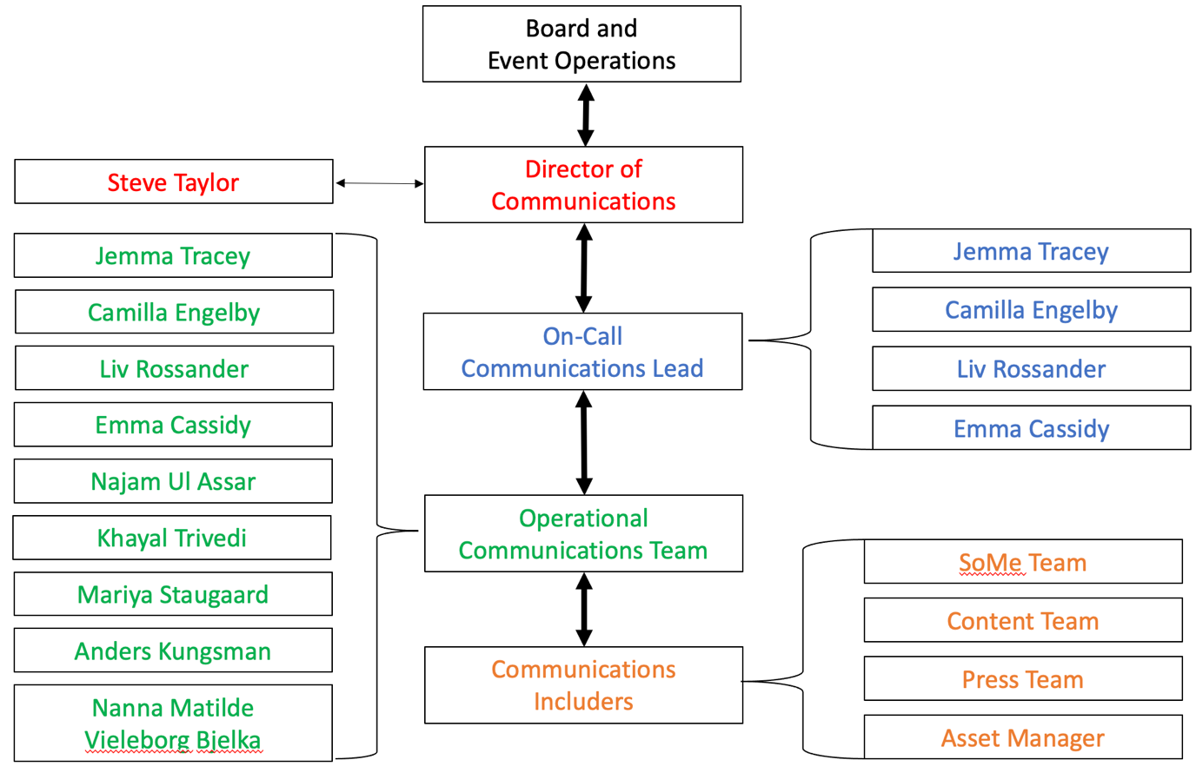

3. Includers and their roles

Copenhagen 2021’s volunteers are named ‘Includers’ to reflect the #YouAreIncluded theme of the event. A number of volunteers will work in the Communications Team.

Social Media Officers will work on Sprout Social to schedule posts and live post across our channels (Facebook, Instagram, LinkedIn, Twitter, YouTube) and monitor incoming messages and answer queries. They will also monitor the content inbox to which anyone can submit images or video for publication.

Asset Manager will manage the content inbox and file and record all incoming video and photo content.

Press Officers will assist in media management, dealing with media enquiries and arranging interviews for spokespeople.

Photographers and Videographers will capture images and video from across events and submit the content to the Asset Manager.

4. Communications Centre / Locations

The Communications Centre in Copenhagen is the ‘home’ of the Comms Team during the event. There are three rooms: the Comms Centre which will be the hub for our social media, content curation, media management and Zendesk tickets; the Press Room which is a space for journalists to work: and a Lounge. Capacity is approx. 30 people and Coronapas is required to be shown upon entry.

Location: First floor, Industriens Hus, HC Andersens Boulevard 18, 1553 Copenhagen.

Opening hours: Thursday 12 to Sunday 15 August, 0900-2000
Monday 16 to Thursday 19 August, 0800-2200
Friday 20 August, 0800-2300
Saturday 21 August, 0800-0100
Sunday 22 August, 0900-1800

Access: All staff and board members (with black accreditation) and all media (red) pass holders. Industriens Hus security will not give access without these passes.

The Communications Centre will have a dedicated phone number which will be shared amongst the team. This should be used only for urgent conversations.

Other key locations for the Communications Team (aside from events themselves) will be the Accreditation Centre (Axel Towers), the Happy Copenhagen office (HC Andersens Boulevard 27), and the location for Press Conferences (CPH Conference and Villa Hotel).

5. Link with Safety Team / Safety Messages

The Safety Team are responsible for security and safety at all events that Happy Copenhagen has organised (not for external events such as those organised by culture partners). They need to rely on the Communications Team for dissemination of important safety announcements and updates.

Phone numbers for all members of the Communications and Safety Teams will be shared before the event and displayed on the wall of the Communications Centre.

The Communications Centre will have a dedicated email for urgent requests, and this will be shared with the Safety Team, and selected partners (Metro, Police etc) who may also need us to issue urgent messages.

The Communications Centre has a bulk SMS capability to send messages to all Includers, all Happy Copenhagen staff, or both. These can be used to provide general updates (i.e. ‘All shifts have now ended. Please return to your sign-in point to sign out.’) and also to send critical updates in the event of an incident. Bulk SMS is more reliable than messaging platforms that rely on data (such as email or WhatsApp) as the messages are more likely to be delivered.

6. Safety Messaging, Logging & Escalation Procedure

Safety Messaging

From time to time the Communications Team may need to support the Safety Team and partners by issuing urgent safety messaging, for example ‘Rådhuspladsen Metro is very busy and entrances are closed. Please use Gammel Strand, Nørreport or København H’. There will be a bank of pre-prepared safety messages that can be used.

Logging

We will use Asana to log all relevant communications or contacts in relation to any issues that arise or incidents that occur. This ensures that all logs are timestamped and cannot be deleted. A log should be created for any:

- Complaint (about any person, event, content or venue)
- Crime that we are made aware of that occurred at any of our events
- Accident or injury that we are made aware of that occurred at any of our events
- Communication of concern (on any communications platform)

The On Call Communications Lead will check the log every hour but the social media and communications Includers will be instructed to inform them immediately should any of the logs relate to a live situation that is ongoing. The On Call Communications Lead will then liaise with the Safety Team or the Malmö Team over what action (if any) is necessary.

The log will record:

- WHAT happened
- WHERE it happened
- WHO was involved
- WHICH staff members (if any) were present
- WHAT action has been taken

Escalation Procedure

The escalation procedure is used to escalate awareness of an incident within the structure (under 2, above), not escalate the severity of the incident. It is the responsibility of the On Call Communications Lead to escalate within the above structure any issue or situation of concern, particularly any occurrence that:

- Is a serious and substantiated complaint
- Involves an injury to a person or people at an event
- Involves a crime committed at an event
- Risks reputational damage to Happy Copenhagen, Copenhagen Pride, Pan Idræt or Malmö Pride

The On Call Communications Lead should immediately decide whether or not regular external communications should be halted and advise colleagues immediately. This will include using the Pause All function in Sprout Social. Whilst this is a major step to take, it is always best to err on the side of caution and pause activity until it can be checked with the Director of Communications.

To escalate, the On Call Communications Lead sends a message in the Communications Team Chat on Telegram, beginning ‘ESCALATION’ followed by a short description (if the escalation is between 2300 and 0800 the On Call Communications Lead should call the Director of Communications).

The Director of Communications will then call that person to discuss what, if any, actions need to be taken. In the event that the Director of Communications cannot be reached within 10 minutes, the On Call Communications Lead will call the Managing Director and, if he cannot be reached, then the Chair.

The Director of Communications will decide on what action needs to be taken and will discuss responses with the Managing Director and/or Chair should the situation be deemed serious enough for their input.

7. Incident Communications Protocol

An incident is any occurrence that has the potential to seriously affect the event or people in attendance. Only the Safety Team have the authority to declare an incident.

In the event of an incident, the role of the Communications Team is:

- To immediately halt all external communications, both live and scheduled, using the Pause All function on Sprout Social
- To be hyper aware and vigilant of any members of the media who are present in the Communications Centre (but they should not be asked to leave immediately; this will be a decision to be made based on the circumstances)
- If agreed, to issue a holding message on social media channels (usually ‘We are aware of an incident at (location) and our Safety Team are managing the situation’).
- To support the Safety Team by monitoring incoming messages for information that may be useful to the Safety Team or authorities
- To issue statements and messages agreed with the Safety Team and the Director of Communications and/or the Managing Director and Chair
- To send messages via bulk SMS to staff and/or Includers as required
- To ensure that no staff or board member gives any interview or comment to the media without the written (email or SMS) approval of the Managing Director
- To issue press statements and organise press conferences by agreement with the Chair, Managing Director, and Director of Communications who will align communications with the authorities.

When an incident is declared, all members of the Communications Team who are on duty should go immediately to the Communications Centre. If the Communications Centre is closed or cannot be reached, an alternative location will be stated in the Telegram channel.

The Director of Communications will liaise with the Head of Safety on where communications staff should go. This may include embedding communications staff at the Safety Office, at the police control or at any other location.

For the purposes of external communications, the Incident Communications Plan remains in place until the Director of Communications or Managing Director states otherwise.

Malmö incidents

In the event of an incident in Malmö, a member of the Malmö team will inform the Managing Director who will cascade information to the rest of the team. We will pause all external communications until the incident has concluded.

The Director of Communications will liaise with the Malmö team to coordinate messages and announcements as necessary.

8. Authorised Spokespersons

The following staff and board members are authorised to give interviews to media.

Katja Moesgaard, Chair

Benjamin Hansen, Managing Director

Steve Taylor, Director of Communications

With prior authorisation, the following staff and board members are authorised to give interviews to media.

Eva Bøggild, Director of Culture & Identity

Ayhan Can, Director of Sports

Aron Le Fevre, Director of Human Rights

Lars Henriksen, Director of WorldPride

Liv Rossander, PR Consultant

Parent organisations (Copenhagen Pride and Pan Idræt) have their own authorised spokespersons but as courtesy are asked to inform our Communications Team before giving any media interviews so that we can brief them on any relevant matters.

Interview requests

Staff and volunteers at Copenhagen 2021 venues and events may be asked by journalists for impromptu interviews or comment. All staff, board members and volunteers will be briefed to the following:

- Board Members, Directors and Managers may answer simple programmatic questions from journalists but must avoid being drawn into interpreting events or giving personal views
- Requests for interviews, or for comments that draw opinion rather than fact, must without exception be referred to the Communications Centre; all accredited media will know that all interviews must be arranged through the Communications Centre

Aligning our messaging and top lines is never more essential than during our event and the Communications Team relies on the whole team to respect this model for dealing with interview requests.

